
Gyeonggi Academy of Foreign Languages
International Department
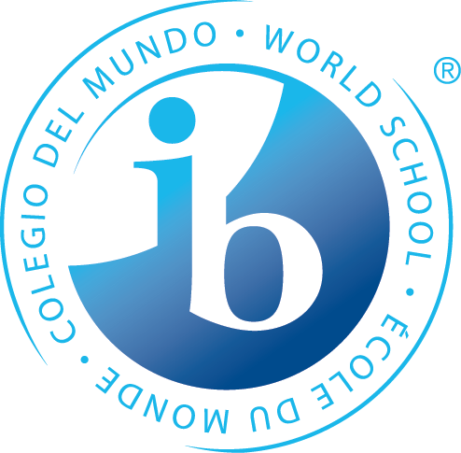
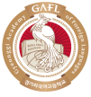
IB Program
Application for 2019

Please complete this form in English
The form should be emailed by 3pm Monday the following address – gmlwjd214@gafl.hs.kr
Please also submit a jpg or png copy of a recent photo
Payment of 30,000won should be made to the GAFL school account (우리은행1005-702-649408)

Personal Details
Full Name (in English)

Full Name (in Korean)

Preferred name (in English)

Date of Birth

Languages Spoken

Email Address
(This should be your email address, not your parents)

Schools Attended for Elementary School and Middle School
Please note – if the school is outside Korea, please include name of the town/city, state and country.
Name of School | Location | Grades Completed | Years Attended  (e.g. 2010-2018)
Gyeonggi Elementary School | Uiwang | Grade1~6 | 2010~2015
Dangjung Middle School | Gunpho | Grad7~9 | 2016~2018

Subject Results
Please list the results for the subjects you have taken at school.
Subject | Result  Semester 1 - 2018 | Result  Semester 2 - 2018 | Result  Semester - 2017
Korean | 87/100 | 75/100 | 82/100
English | 90/100 | 92/100 | 93/100
Science | 87/100 | 88/100 | 90/100
Math | 87/100 | 75/100 | 82/100
If you have more Main Subject, you Can put the grade.

- If the grade is by Letter, write ‘A’ or ‘B’
- Enter Data for last 3 semester
- If you have any question, please contact 031-361-0613(윤희정 국제교육지원팀장)

Questions
Please answer the following questions.(If you need more spaces, you can use more space in the box

- What are your reasons for applying for a position in the IB Diploma Program at Gyeonggi Academy of Foreign Languages?

- What major do you want to do at university/college when you leave high school? Why have you chosen this particular major? Where do you want to study this major?

- What are your favorite subjects at school and why?

- What activities do you participate in both at school and outside school? (For example, sport, dance, theatre, debating, music, service etc.)

