
Gyeonggi Academy of Foreign Languages
International Department
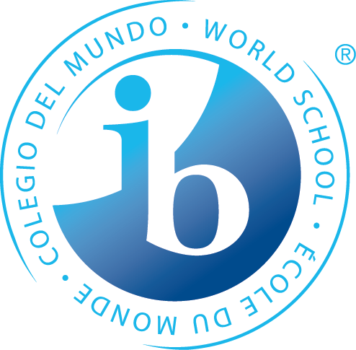
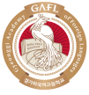
IB Program
Application for 2018

Please complete this form in English
- The form should be emailed by 11pm Sunday February 25th, to the following address - dainsong@gafl.hs.kr
Name:
Student number (Current):
Phone number:
E-mail Address:

Questions
Please answer the following questions.

- What are your reasons for applying for a position in the IB Diploma Program at Gyeonggi Academy of Foreign Languages?

- What major do you want to do at university/college when you leave high school? Why have you chosen this particular major? Where do you want to study this major?

- What are your favorite subjects at school and why?

- What activities do you participate in both at school and outside school? (For example, sport, dance, theatre, debating, music, service etc.)

